Capstone Project-1 [E-Commerce App]:

Front end Development (HTML, CSS, Bootstrap 5, JavaScript)

I have Created the UI design of the e-commerce website, which the users will be using to browse and purchase the products. This is the first part of the product. Here I am working only on the front-end part of this project. I have used downloaded bootstrap and JS in this project. I have Build an E-commerce website UI with the following features/pages:

[This Website is Fully Responsive.]

Link Of This Website: https://648ae65869319503ed3f6a52--radiant-pixie-9bbd90.netlify.app/index.html

1. **Header:** A header with 2 parts – the first part contains the logo, search box, and the cart and login buttons. The second part is the navigation bar that contains the links to the products and the categories. Women and Men are Dropdown Menu.

**Output of the Header:**

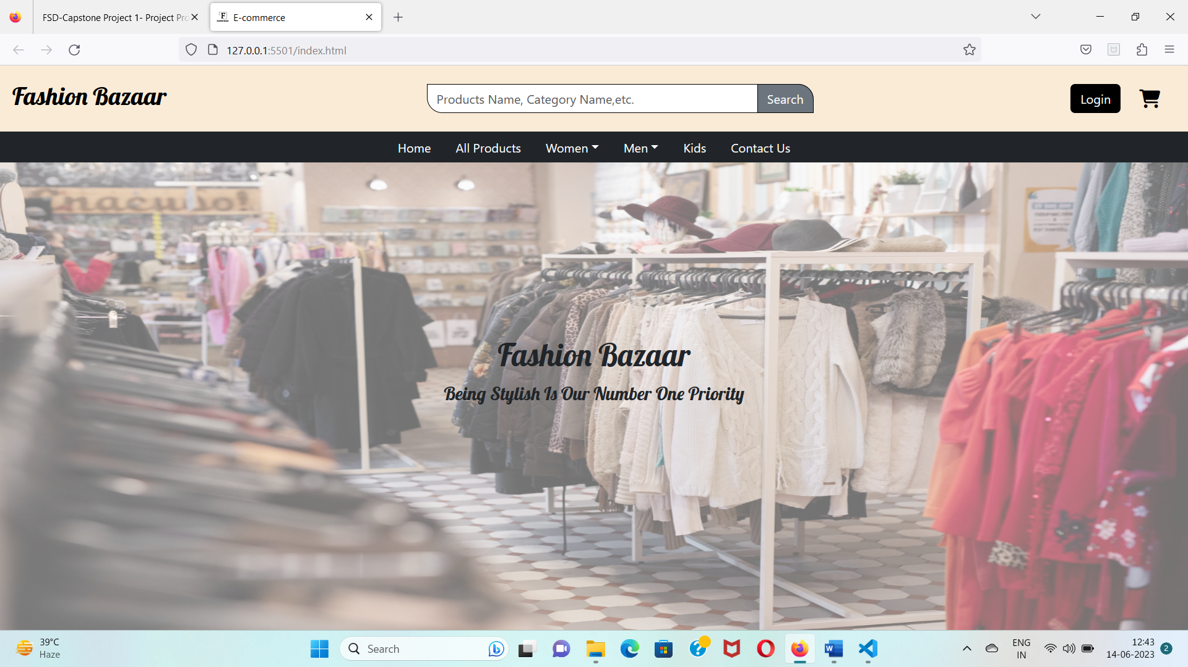

**In small devices Header look like this:**

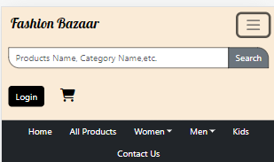

1. **Footer:** A footer that again lists the categories and links, with a copyright message at the end.

**Output of the Footer:**

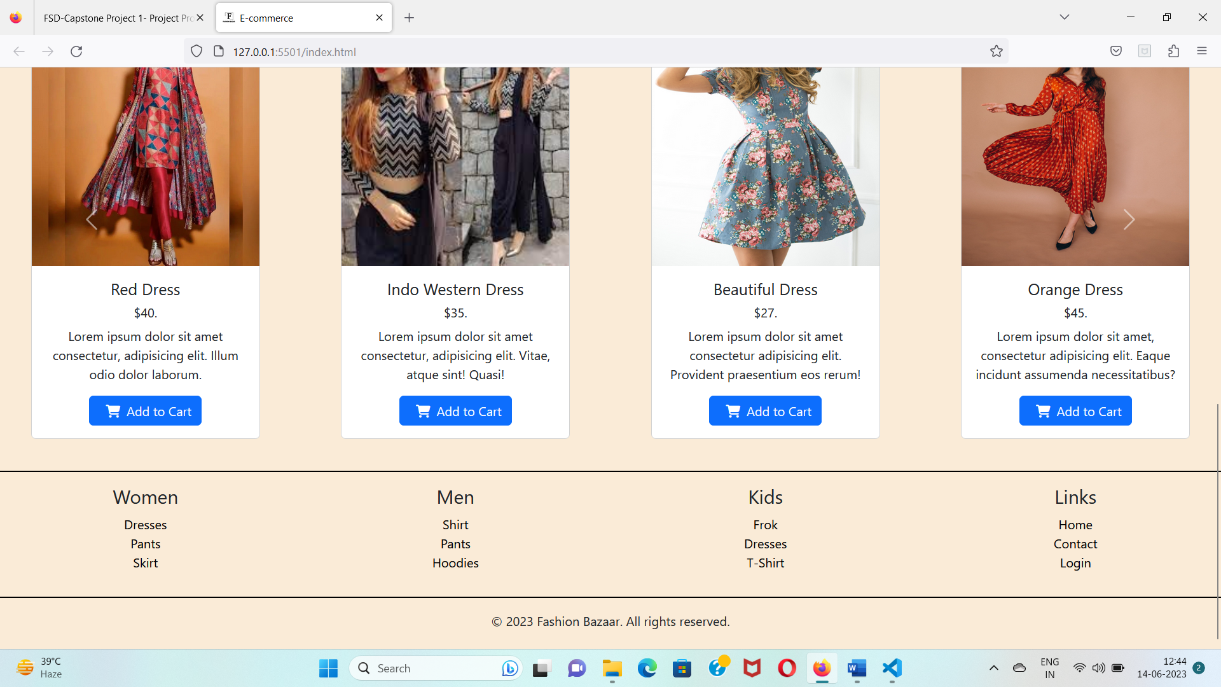

[ I used Common header and Footer in all the pages. I dynamically inject header and footer in all the pages using Javascript to save time and avoid the repetition of code.]

1. **Home Page:** A home page that contains a cover image with the company’s slogan right below the header and a slider that lists the featured products (right above the footer).

**Output of the Home Page:**

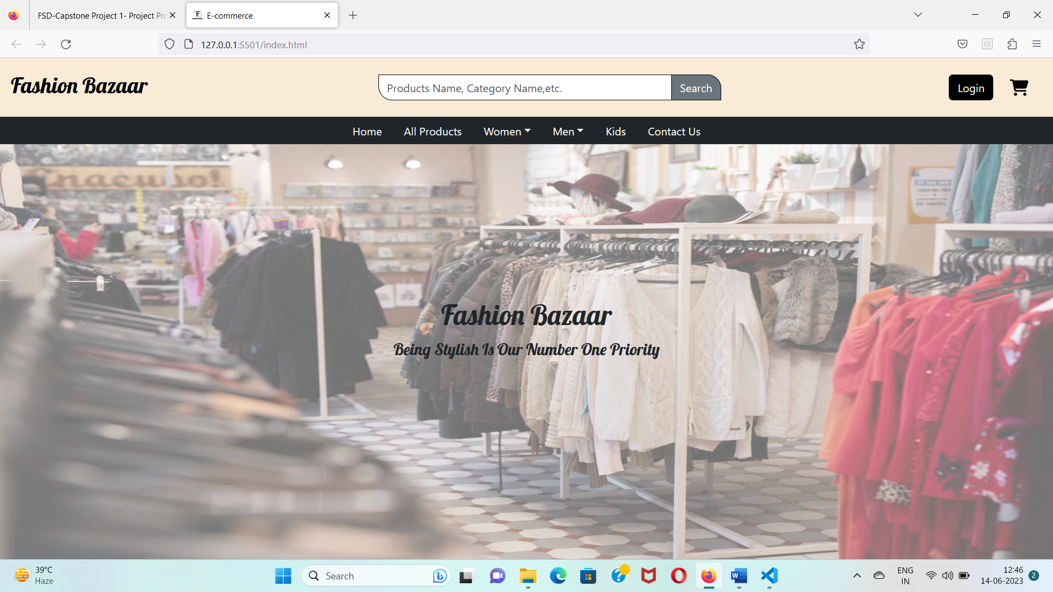

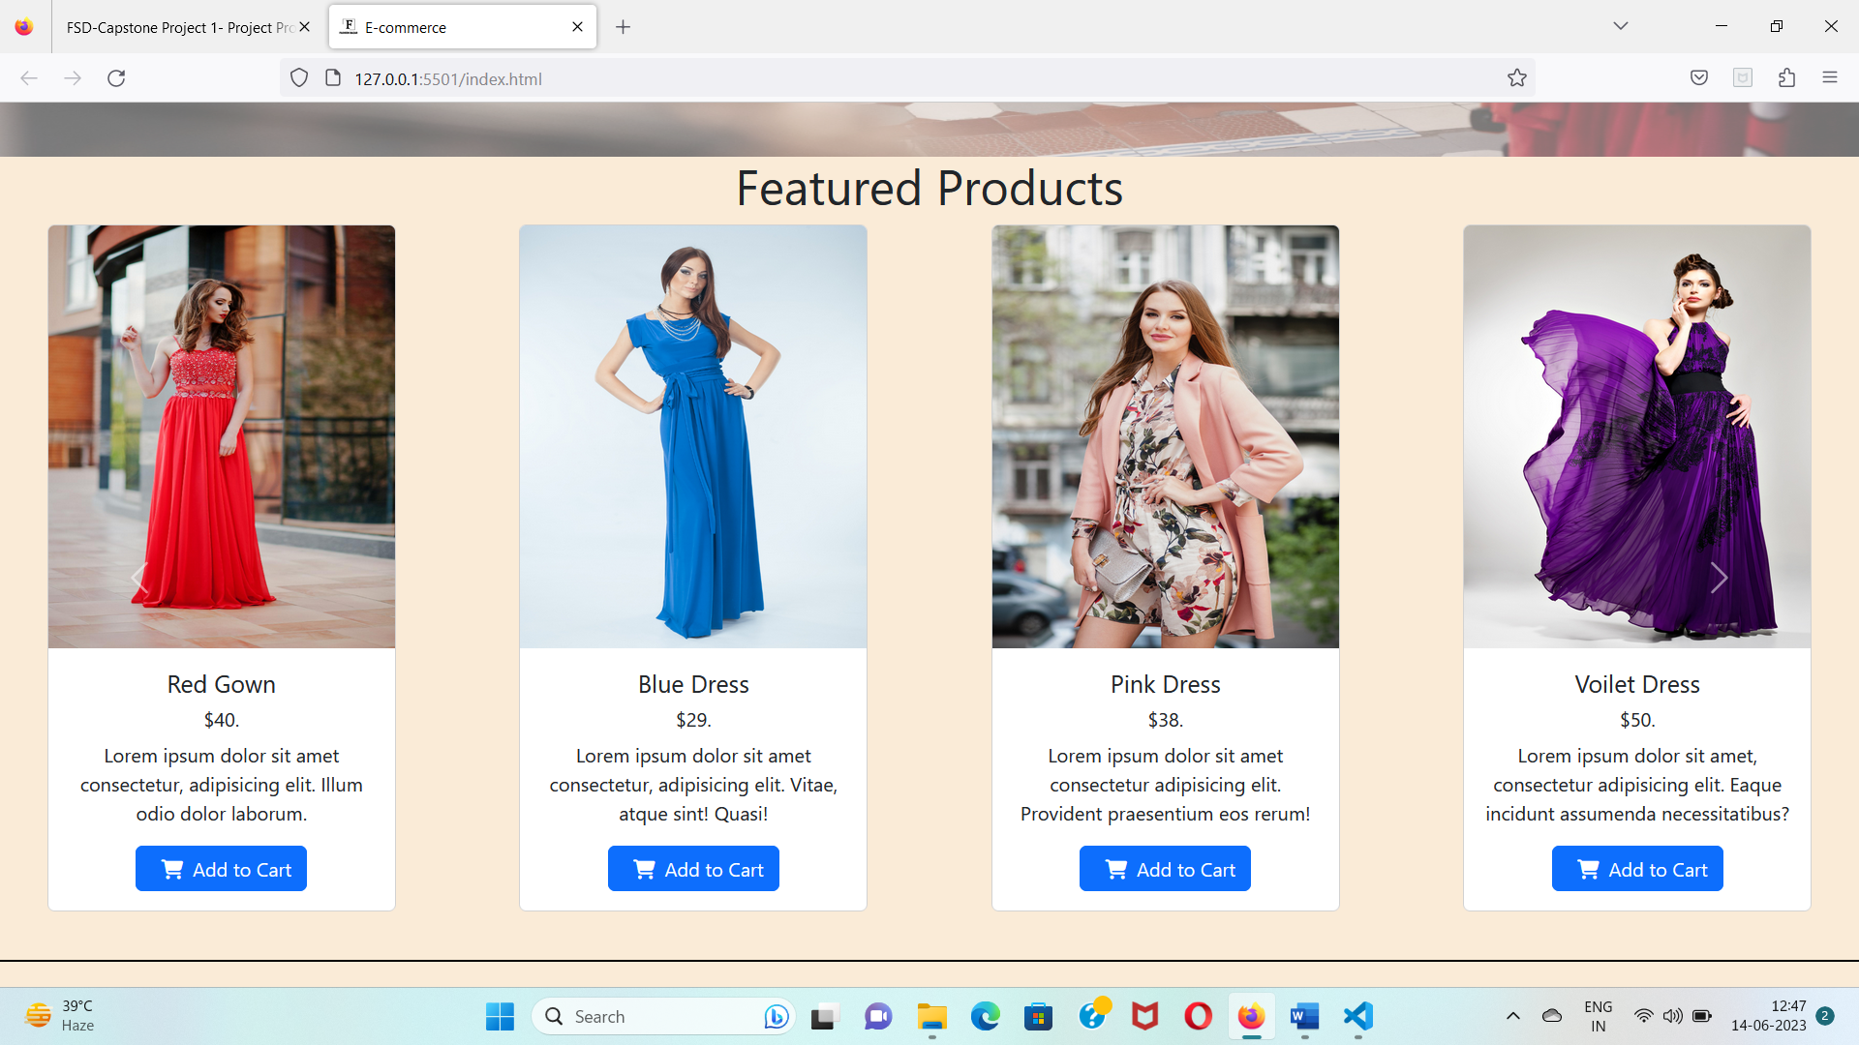

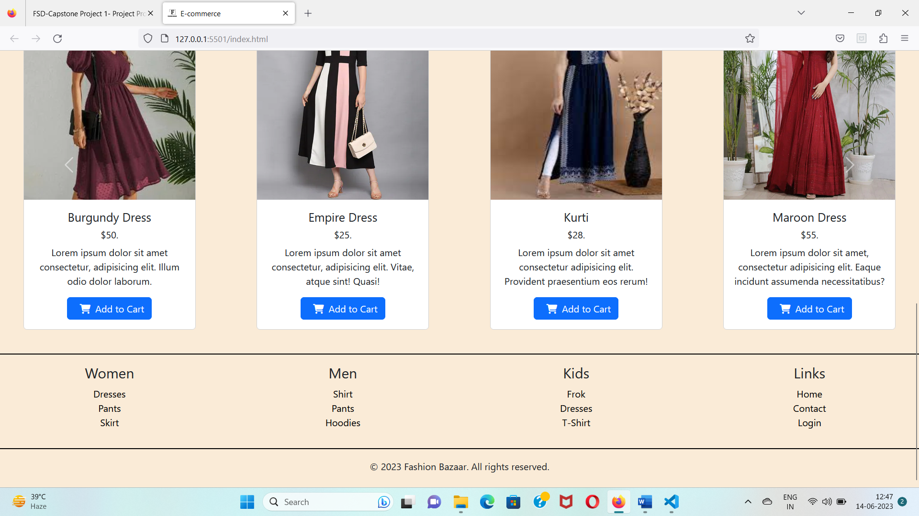

**4. Product Pages:** Following are the product pages:

**A.** All products page that lists all the products in a grid format.

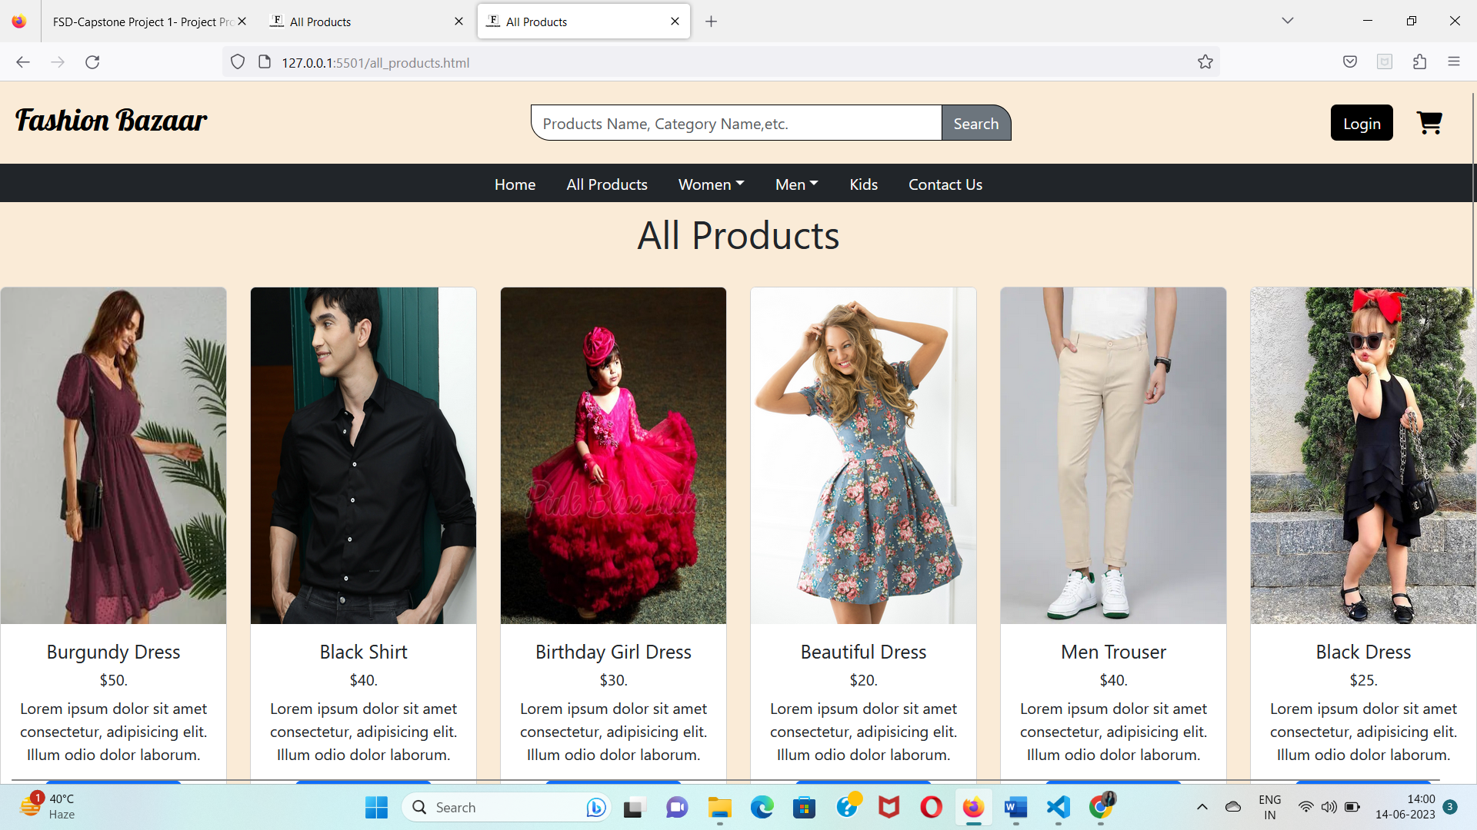

**B. Women’s category page with the following sub-categories:** All Womens products pages that lists all the products in a grid format.

**i. All Products Page of Women Category:**

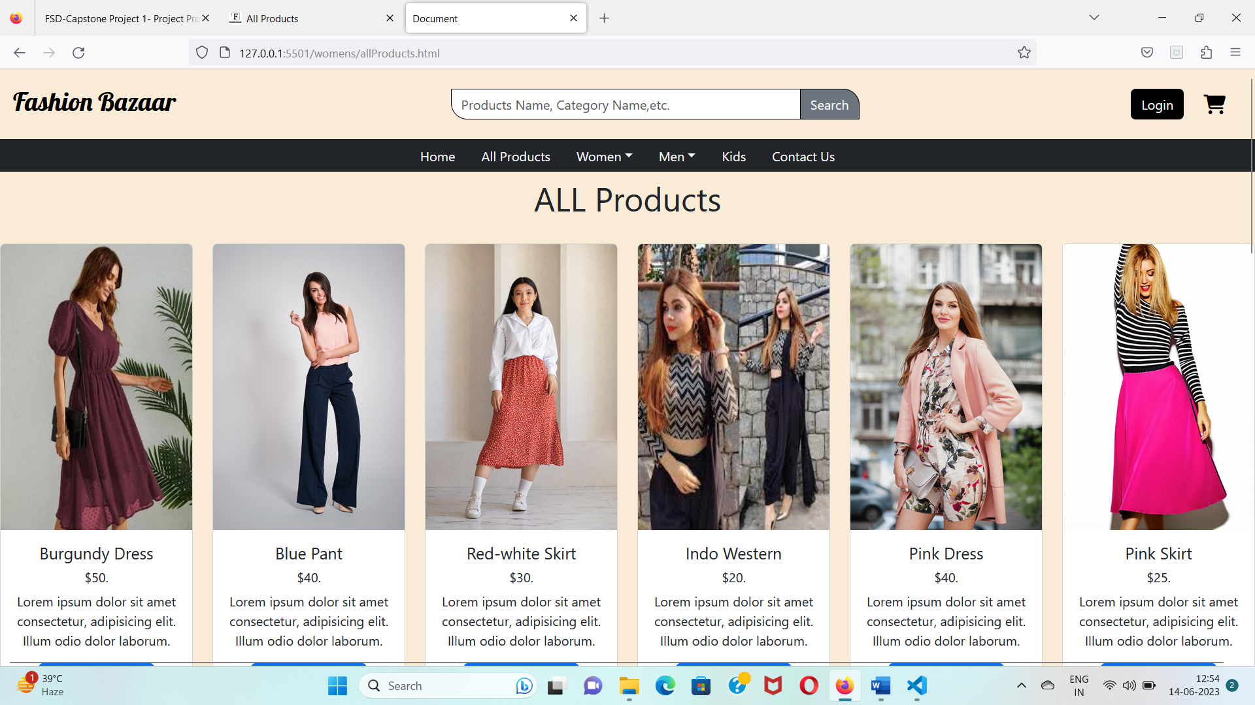

**ii. Dresses Page of Women:**

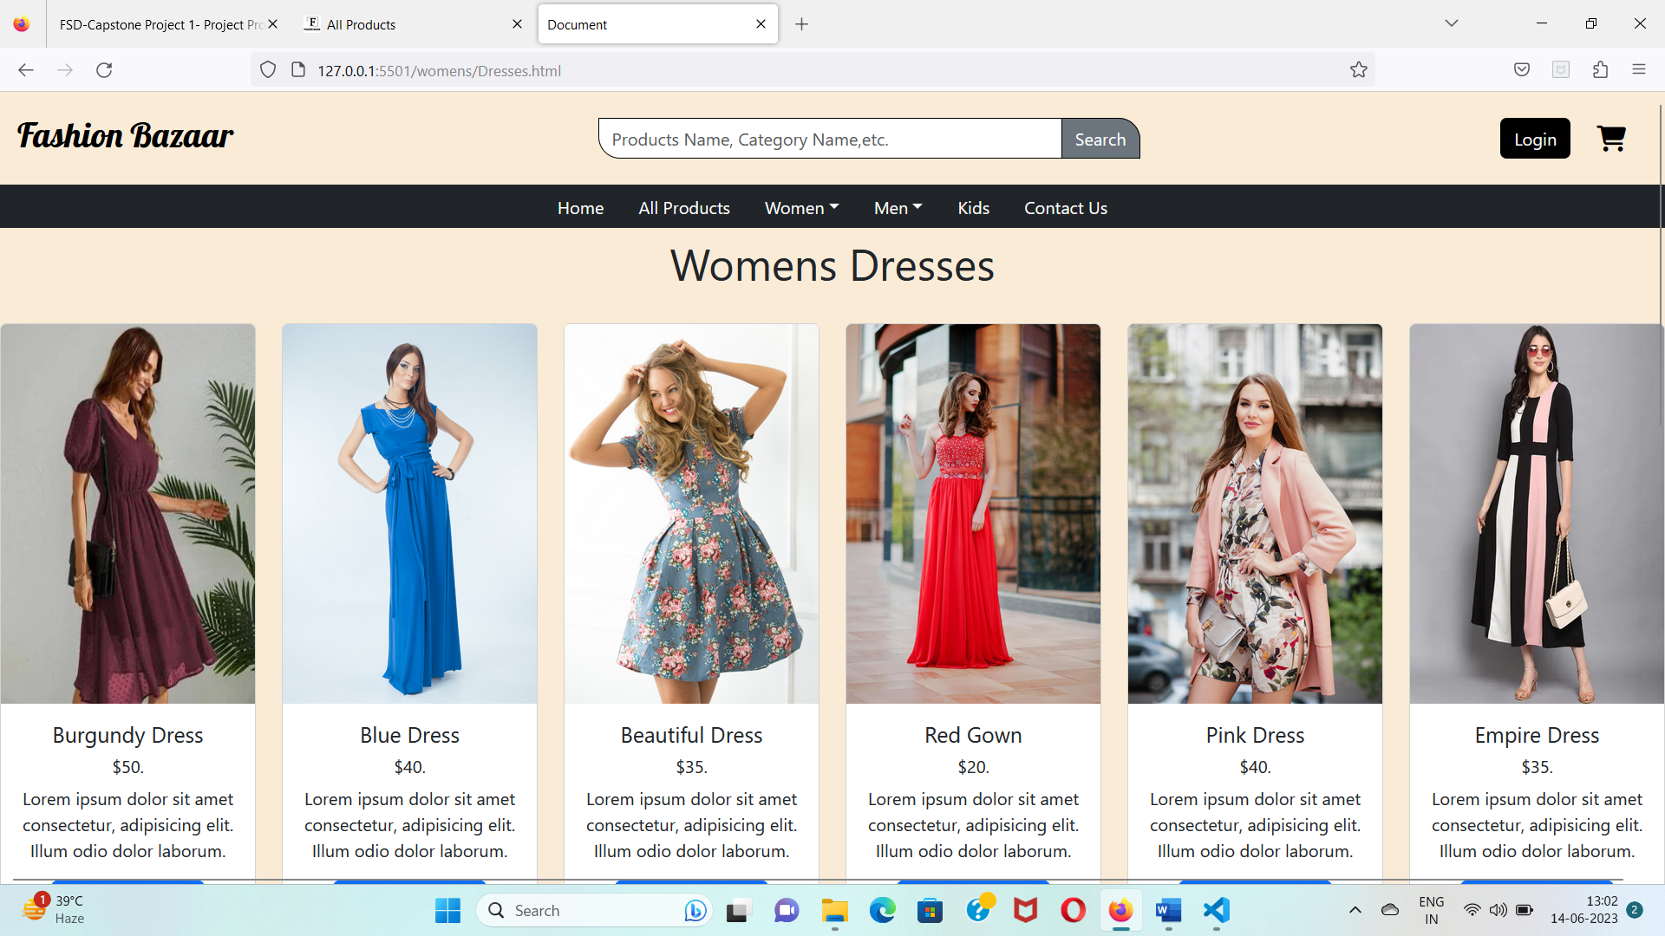

In Medium Devices it look like this:

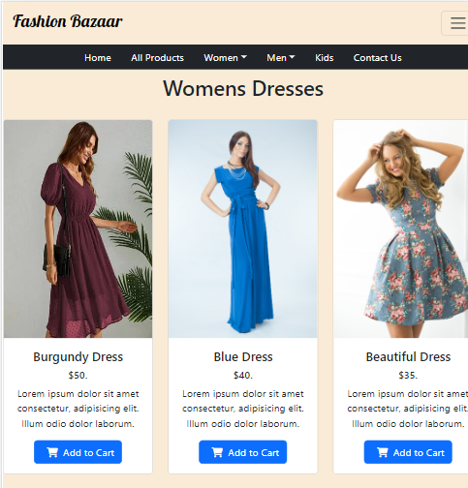

In Small Devices it look like this:

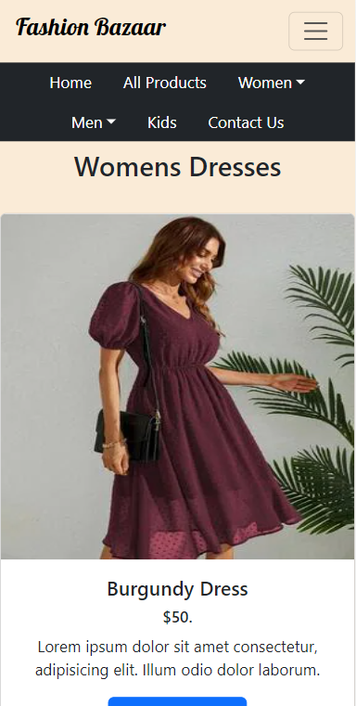

**iii. Pants Page of Women:**

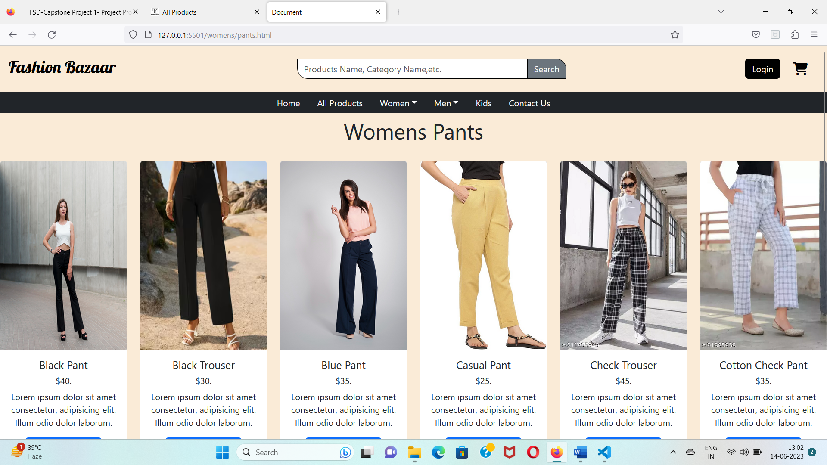

**iv. Skirts Page of Women:**

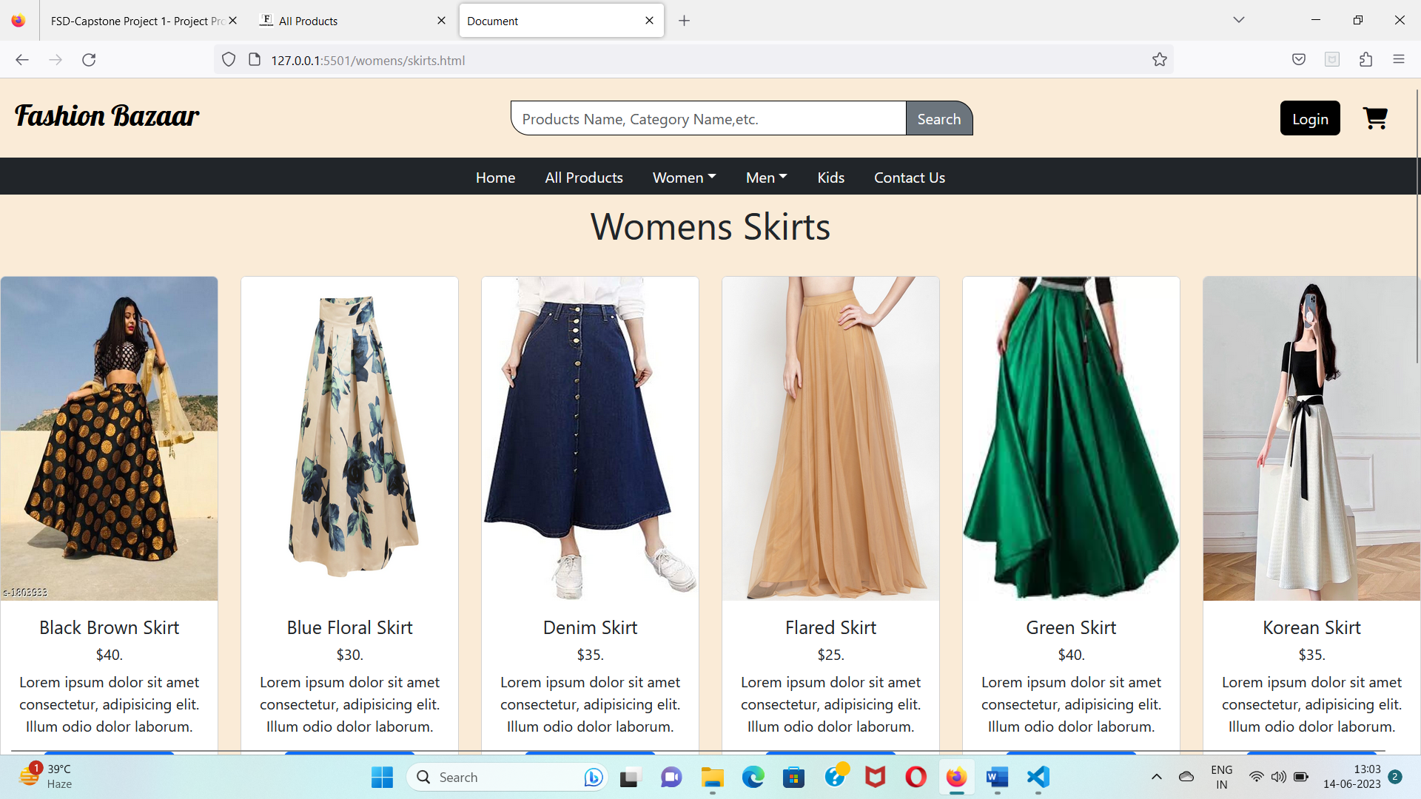

**C. Men’s category page with the following sub-categories: :** All Mens products pages that lists all the products in a grid format.

**i. All products Page Of Men Category:**

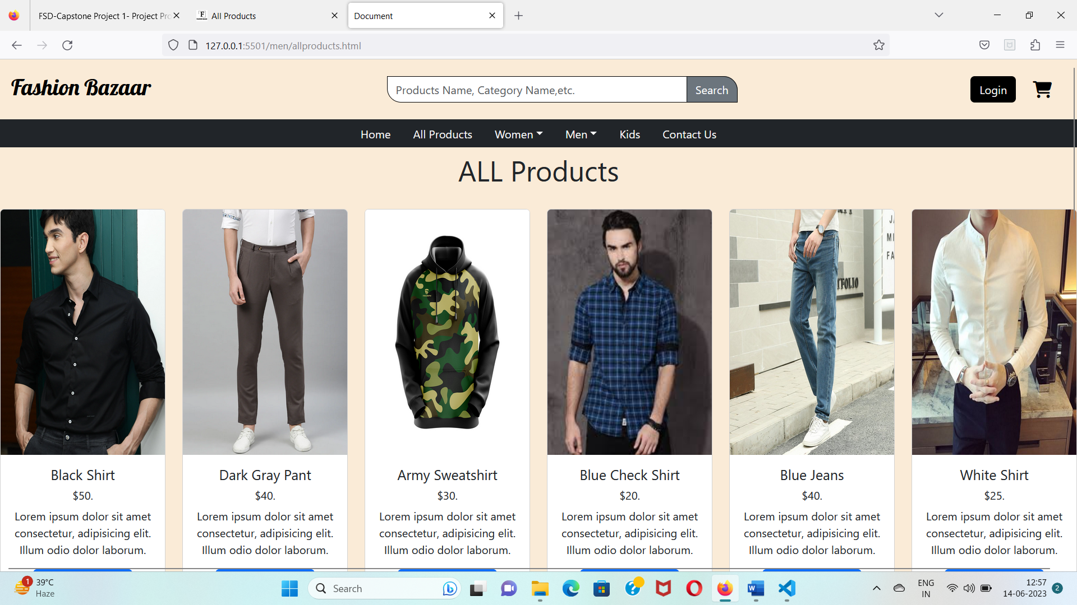

**ii. Shirts Page of Men Category** 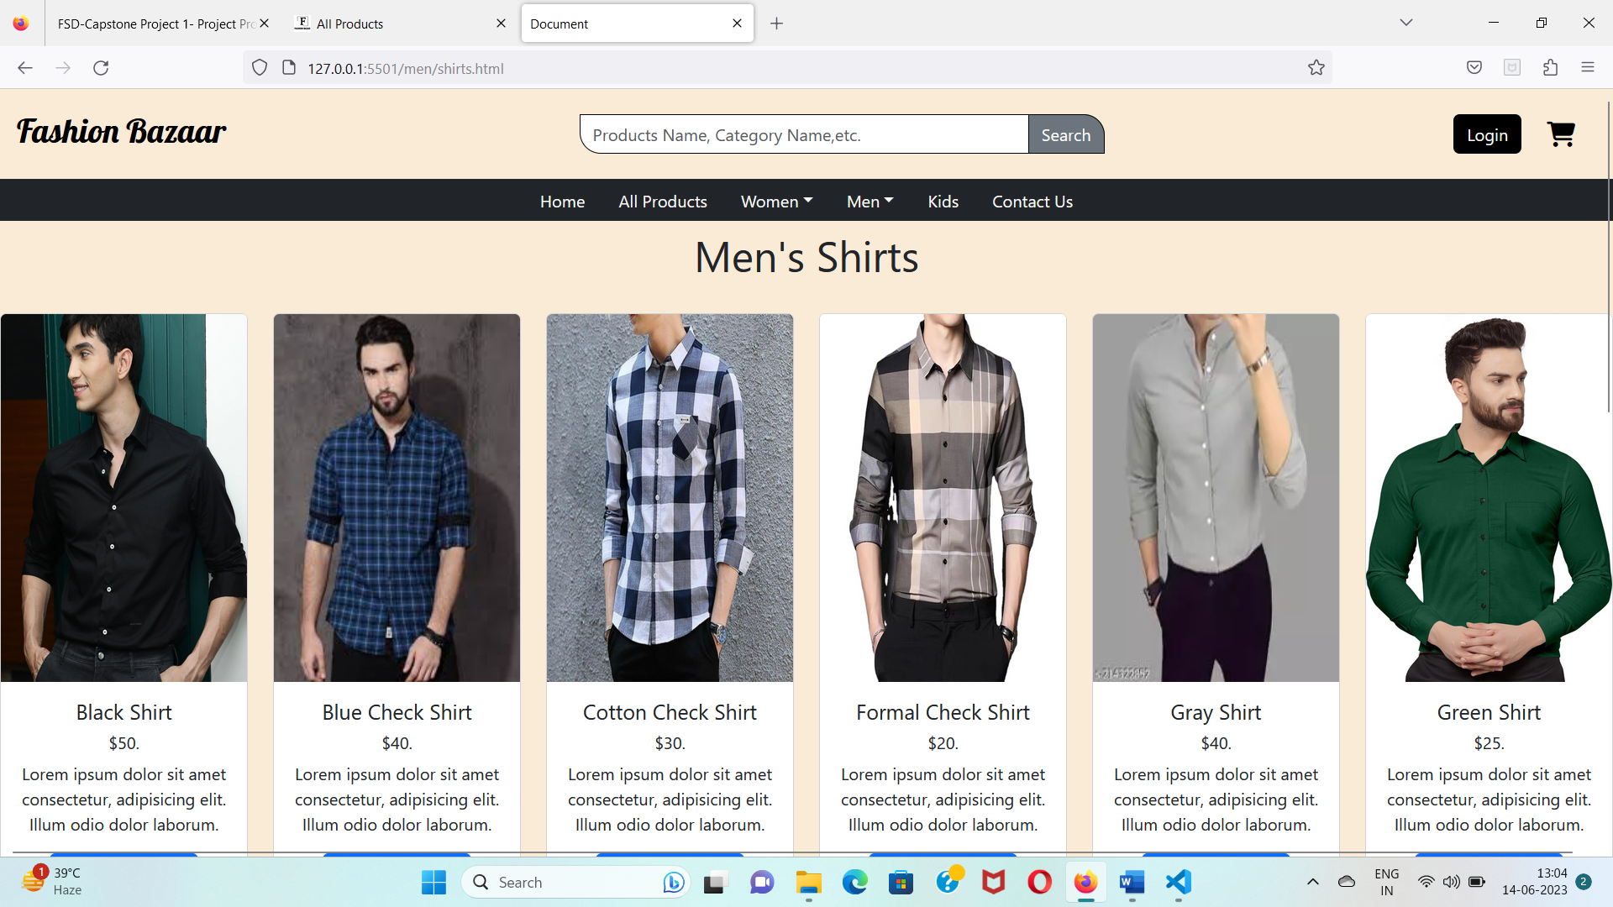

**iii. Pants Page of Men Category:**

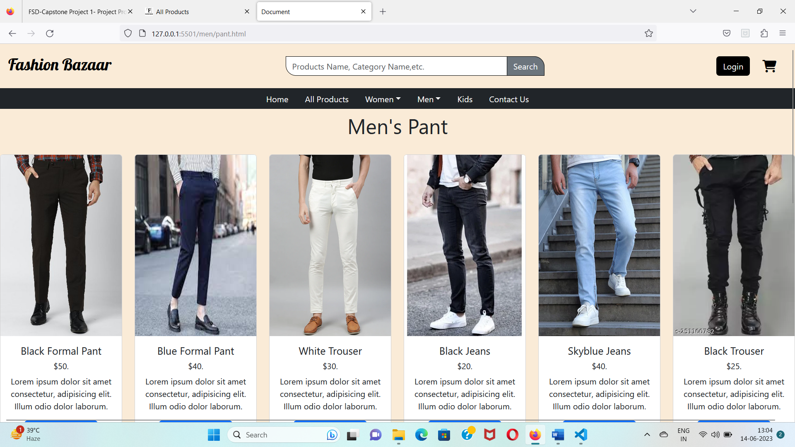

**iv. Hoodies Page of Men Category:**

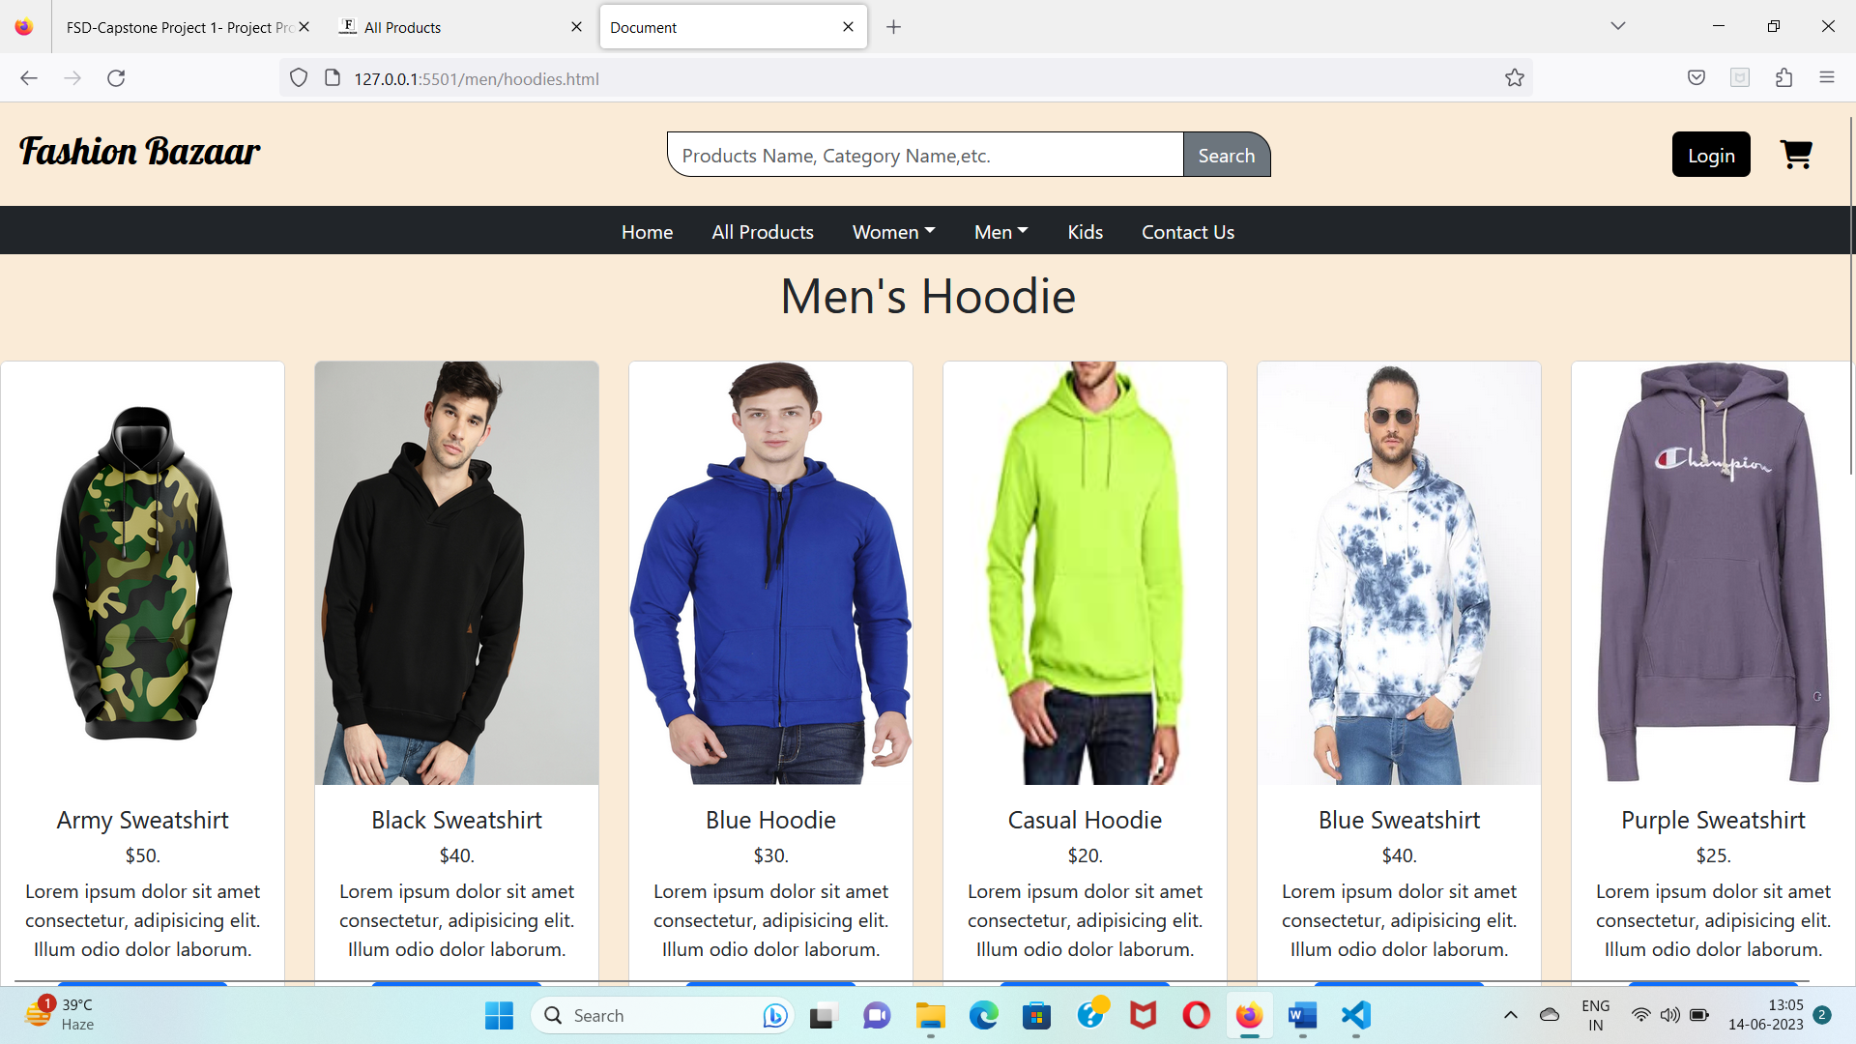

**d. A kids category page that lists all the kid clothes:**

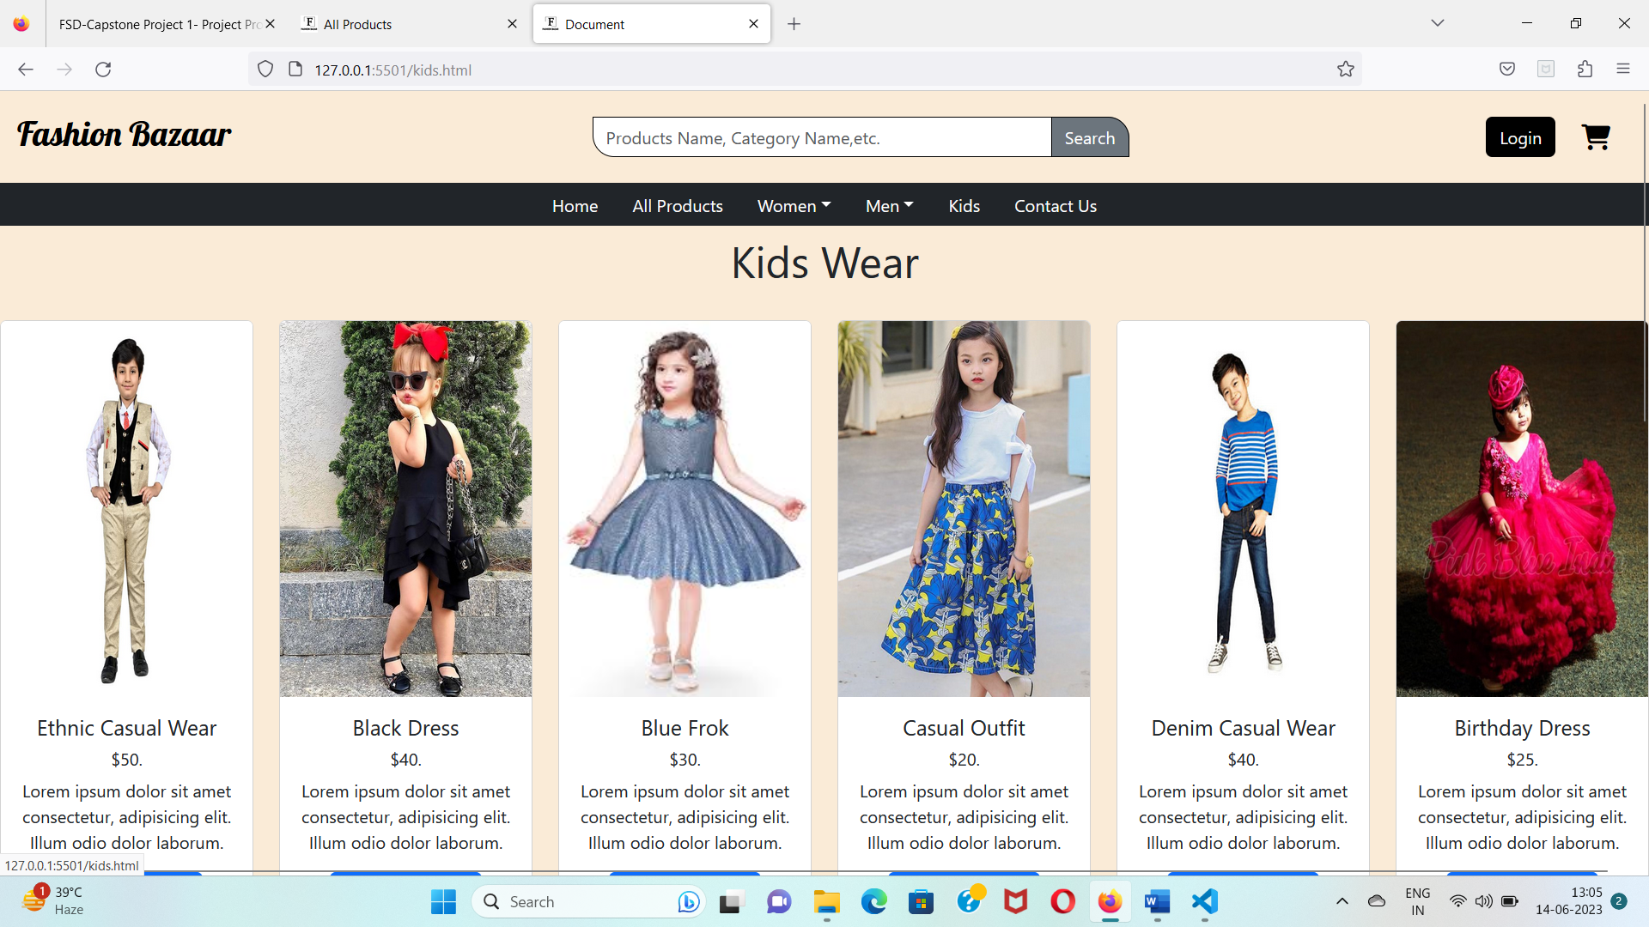

**5. Contact Us Page:** I have created a decent-looking contact us page that asks for the user’s name, e-mail, and message.

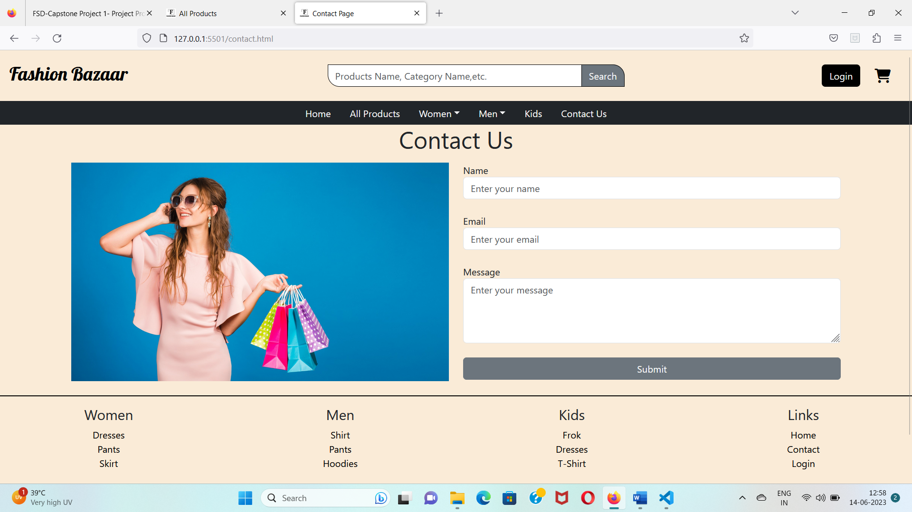

**6. Login Page:** A login page that asks for the user’s E-mail and password. When you enter correct E-mail[admin@admin.com] and Password [123456] it gives a popup of login Successful otherwise it gives a popup of incorrect email or password.

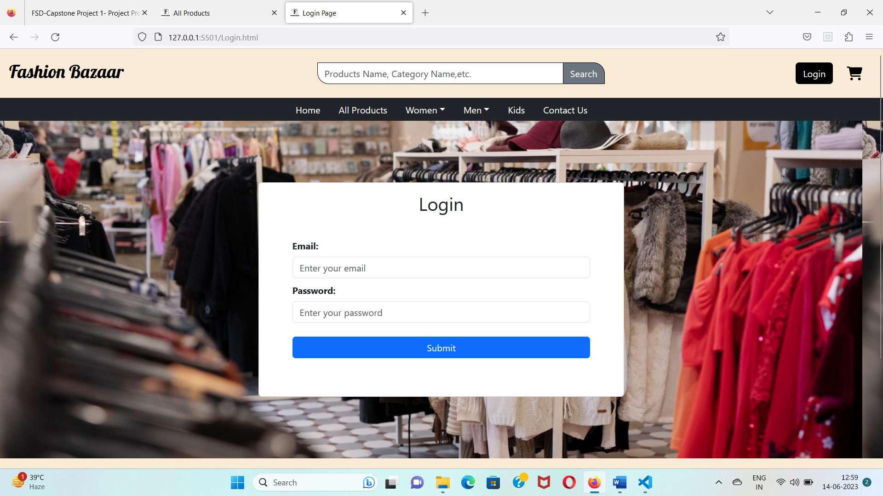

**7. Cart Page:** A cart page that lists all the products which we have added to our cart, with a “+ and –” button to increase and decrease the product quantity and a delete button to delete the product from the cart. I make these buttons and features work later. For now, I just create the design.

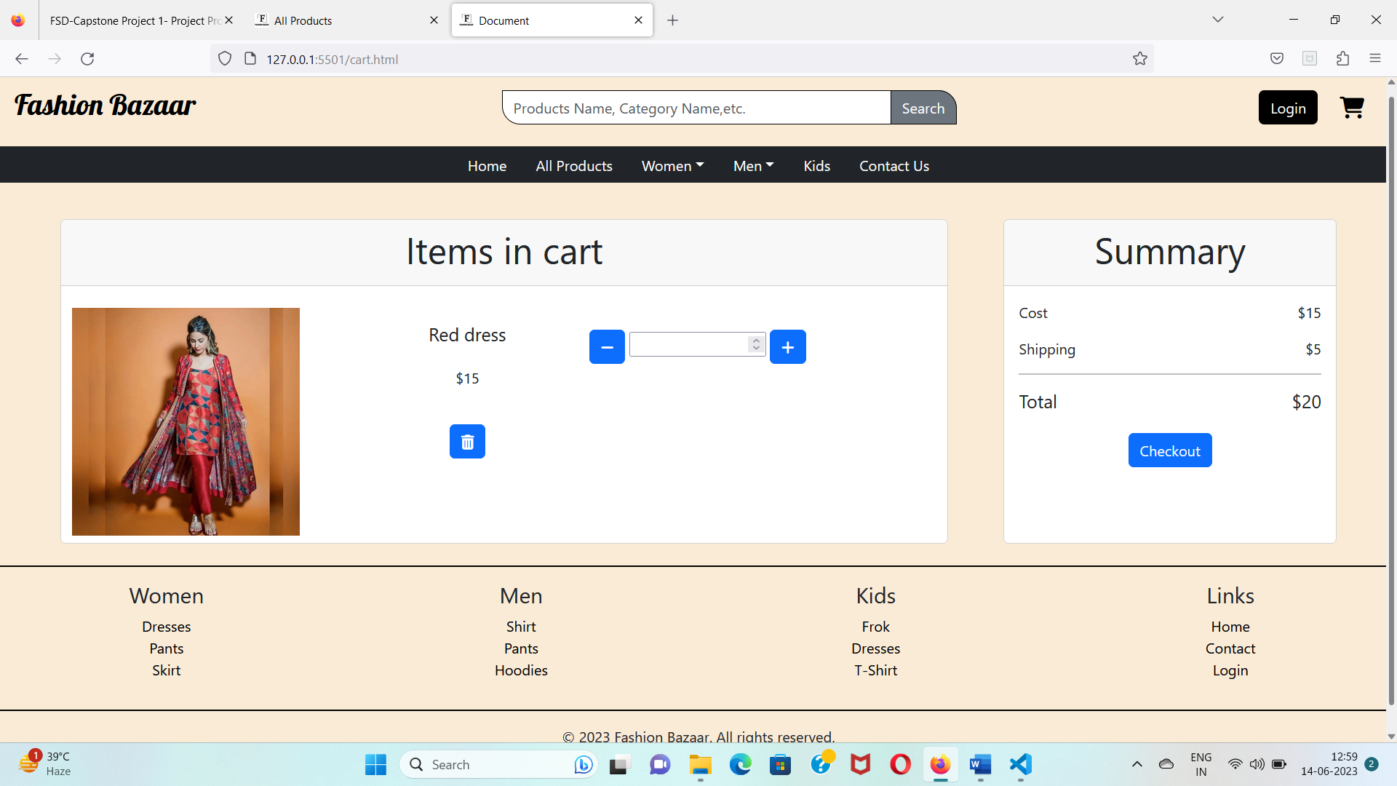

**Thankyou!**